Incoming Material Inspection Procedure
Manufacturing Knowledge Hub | Quality Assurance | Owner: Linda Park | Last updated: October 30, 2026

Section 1: Executive Summary & Scope
Defines the sampling plan, acceptance criteria, and disposition process for raw materials received from approved suppliers. Section 1 (Executive Summary & Scope) applies to Quality Assurance within Manufacturing Knowledge Hub and is maintained by Linda Park. Defines the operational charter, scope boundaries, and executive accountability.
Operational requirement 1.1: Sampling follows an AQL 1.0 plan based on lot size per ANSI/ASQ Z1.4. Secondary control 1.2: Dimensional checks use calibrated gauges logged against the calibration schedule.
- Sampling follows an AQL 1.0 plan based on lot size per ANSI/ASQ Z1.4.
- Dimensional checks use calibrated gauges logged against the calibration schedule.
- Section 1 review cadence is tracked by Linda Park under Quality Assurance governance.
Control Area | Owner | Target SLA | Verification Status
Quality Assurance | Linda Park | 5 business days | Verified
Incoming Material Inspection Gate 1 | Linda Park | 3 business days | Active
Incoming Material Inspection Gate 2 | Linda Park | 10 business days | Monitored
Page 1 of 5 | Manufacturing Knowledge Hub | Quality Assurance | SharePoint Online

Section 2: Architecture & Process Flow
Defines the sampling plan, acceptance criteria, and disposition process for raw materials received from approved suppliers. Section 2 (Architecture & Process Flow) applies to Quality Assurance within Manufacturing Knowledge Hub and is maintained by Linda Park. Maps end-to-end process stages, handoff gates, and system-of-record integrations.
Operational requirement 2.1: Dimensional checks use calibrated gauges logged against the calibration schedule. Secondary control 2.2: Nonconforming lots are quarantined and tagged pending Material Review Board decision.
- Dimensional checks use calibrated gauges logged against the calibration schedule.
- Nonconforming lots are quarantined and tagged pending Material Review Board decision.
- Section 2 review cadence is tracked by Linda Park under Quality Assurance governance.
Control Area | Owner | Target SLA | Verification Status
Quality Assurance | Linda Park | 5 business days | Verified
Incoming Material Inspection Gate 1 | Linda Park | 3 business days | Active
Incoming Material Inspection Gate 2 | Linda Park | 10 business days | Monitored
Sec-2 | Linda Park | 3 business days | Stage 2 Verified
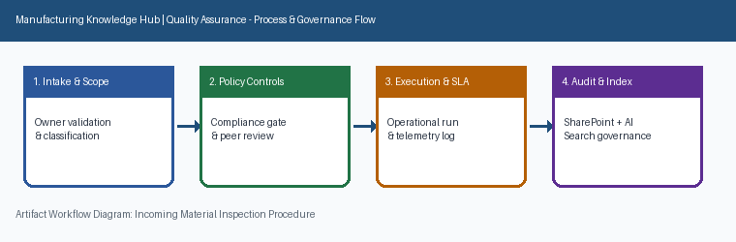
Page 2 of 5 | Manufacturing Knowledge Hub | Quality Assurance | SharePoint Online

Section 3: Governance Standards & Controls
Defines the sampling plan, acceptance criteria, and disposition process for raw materials received from approved suppliers. Section 3 (Governance Standards & Controls) applies to Quality Assurance within Manufacturing Knowledge Hub and is maintained by Linda Park. Establishes mandatory compliance controls, approval thresholds, and audit evidence.
Operational requirement 3.1: Nonconforming lots are quarantined and tagged pending Material Review Board decision. Secondary control 3.2: Supplier is notified within 24 hours of any lot rejection with supporting measurement data.
- Nonconforming lots are quarantined and tagged pending Material Review Board decision.
- Supplier is notified within 24 hours of any lot rejection with supporting measurement data.
- Section 3 review cadence is tracked by Linda Park under Quality Assurance governance.
Control Area | Owner | Target SLA | Verification Status
Quality Assurance | Linda Park | 5 business days | Verified
Incoming Material Inspection Gate 1 | Linda Park | 3 business days | Active
Incoming Material Inspection Gate 2 | Linda Park | 10 business days | Monitored
Sec-3 | Linda Park | 10 business days | Stage 3 Verified
Page 3 of 5 | Manufacturing Knowledge Hub | Quality Assurance | SharePoint Online

Section 4: Operational KPIs & Benchmarks
Defines the sampling plan, acceptance criteria, and disposition process for raw materials received from approved suppliers. Section 4 (Operational KPIs & Benchmarks) applies to Quality Assurance within Manufacturing Knowledge Hub and is maintained by Linda Park. Tracks baseline performance, target SLAs, and quarterly benchmark progression.
Operational requirement 4.1: Supplier is notified within 24 hours of any lot rejection with supporting measurement data. Secondary control 4.2: Sampling follows an AQL 1.0 plan based on lot size per ANSI/ASQ Z1.4.
- Supplier is notified within 24 hours of any lot rejection with supporting measurement data.
- Sampling follows an AQL 1.0 plan based on lot size per ANSI/ASQ Z1.4.
- Section 4 review cadence is tracked by Linda Park under Quality Assurance governance.
Control Area | Owner | Target SLA | Verification Status
Quality Assurance | Linda Park | 5 business days | Verified
Incoming Material Inspection Gate 1 | Linda Park | 3 business days | Active
Incoming Material Inspection Gate 2 | Linda Park | 10 business days | Monitored
Sec-4 | Linda Park | 5 business days | Stage 4 Verified
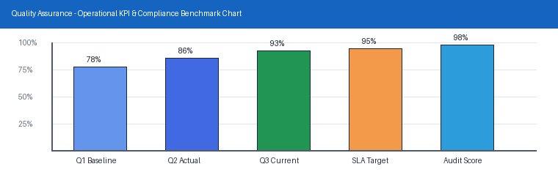
Page 4 of 5 | Manufacturing Knowledge Hub | Quality Assurance | SharePoint Online

Section 5: Appendix, Lineage & Sign-off
Defines the sampling plan, acceptance criteria, and disposition process for raw materials received from approved suppliers. Section 5 (Appendix, Lineage & Sign-off) applies to Quality Assurance within Manufacturing Knowledge Hub and is maintained by Linda Park. Records document lineage, governance metadata, version history, and owner sign-off.
Operational requirement 5.1: Sampling follows an AQL 1.0 plan based on lot size per ANSI/ASQ Z1.4. Secondary control 5.2: Dimensional checks use calibrated gauges logged against the calibration schedule.
- Sampling follows an AQL 1.0 plan based on lot size per ANSI/ASQ Z1.4.
- Dimensional checks use calibrated gauges logged against the calibration schedule.
- Section 5 review cadence is tracked by Linda Park under Quality Assurance governance.
Control Area | Owner | Target SLA | Verification Status
Quality Assurance | Linda Park | 5 business days | Verified
Incoming Material Inspection Gate 1 | Linda Park | 3 business days | Active
Incoming Material Inspection Gate 2 | Linda Park | 10 business days | Monitored
Sec-5 | Linda Park | 3 business days | Stage 5 Verified
Page 5 of 5 | Manufacturing Knowledge Hub | Quality Assurance | SharePoint Online

